

SEMESTER LONG INTERNSHIP PROGRAM (SLIP) REPORT

# Avaya India Pvt. Ltd.

## Submitted By

**Yash Sarnaik**

0120200464

SCHOOL OF COMPUTER ENGINEERING

**Guided By:** Mr. Krunal Pawar

**MIT ACADEMY OF ENGINEERING ALANDI (D), PUNE 2023-24**

MIT ACADEMY OF ENGINEERING ALANDI (D), PUNE

***CERTIFICATE***

This is to certify that the “**Semester Long Internship Program (SLIP)” report,** submitted by **Yash Sarnaik, PRN- 0120200464** is work done by him and is submitted during **2023-24** academic year.

**Faculty Mentor Coordinator School - Internship**

Mr. Nilesh Navghare Mr. Krunal Pawar

# School Dean

Dr. Rajeshwari M. Goudar

# Internship Certificate

***Internship certificate provided by the internship institution***

ACKNOWLEDGEMENT

I want to express my gratitude towards my mentor of **Avaya** Internship **Mr. Madan Kumar**, my reporting manager **Mr. Avinash Shendage**, team members, Faculty mentor **Mr. Krunal Pawar** for their constant encouragement and valuable guidance during the completion of this internship work. I also want to express my gratitude towards respected School Dean **Dr. Rajeshwari Goudar** and School Internship Co-ordinator **Prof. Nilesh Navghare** for his continuous encouragement.

I would be failing in my duty if I do not thank all the other staff and faculty members for their experienced advice and evergreen support.

## Yash Sarnaik

**CONTENTS**

|  |  |  |  |
| --- | --- | --- | --- |
| **Topic** | | | **Page No** |
| 1. | **Introduction** | | 6 |
|  | 1.1 | **Introduction to Avaya** |  |
| **2.** | **Internship Work** | | 7 |
|  | 2.1 | **AXPC Team Report** | 7 |
|  | 2.1.1 | **Task Breakdown** | 7 |
|  | 2.1.2 | **Tools** | 8 |
|  | 2.1.3 | **Implementation Details** | 9 |
|  | 2.1.4 | **Presentation to Key Stakeholders** | 9 |
|  | 2.1.5 | **Gathering Feedback and Finalization** | 10 |
|  | 2.2 | **Bits of Appreciation and Snippet** | 10 |
| **3.** | **Learning Experience** | | 13 |
| **4.** | **Conclusion** | | 15 |

# Introduction:

The corporate world demands that their employees should possess a set of diverse skills to excel in the chosen field. With this motive, I set out on a journey engaging the rewarding internship at Avaya in the month of January. In Avaya Internship, I am assigned to the team of Avaya Experience Platform(AXP) Connect of the Client domain. These experiences have immensely expanded my horizons, improved my technical skills and given me a deeper understanding of the complex nature of corporate operations.

## Introduction to Avaya:

I completed my internship at Avaya working in the AXPC team**. Avaya LLC,** often shortened to Avaya and formerly Avaya Inc., is an American multinational technology company headquartered in Morristown, New Jersey, that provides cloud communications and workstream collaboration services. The company's platform includes unified communications and contact center services. In 2019, the company provided services to 220,000 customer locations in 190 countries.

Since 2001, Avaya has sold and acquired several companies. Through Nortel's bankruptcy proceedings, assets related to their Enterprise Voice and Data business units were auctioned. Avaya placed a $900 million bid, and was announced as the winner of the assets on September 14, 2009. In 1985, Performance Engineering Corporation was formed to offer technology services to government customers. On January 18, 2006, Nortel PEC Solutions was renamed Nortel Government Solutions. On December 21, 2009, Avaya acquired Nortel's government business as part of the company's assets sale. In October 2019, Avaya entered into a strategic partnership with RingCentral and together, introduced a new unified communications as a service solution called Avaya Cloud Office ("ACO"). RingCentral also contributed

$500 million to be the exclusive provider of the new Avaya UCaaS offer.

The company has various departments, and the organization has a functional structure and the hierarchy is based on the same.

# INTERNSHIP WORK:

The tasks I have performed throughout the internship at Avaya are described as follows:

## AXPC Team Report:

My internship at Avaya was a transformative experience that bridged the gap between academic learning and practical application. As a final-year B.Tech student majoring in Computer Engineering, I was eager to contribute my skills to a dynamic and globally recognized organization. I was graced by an amazing opportunity to work with AXPC team in Avaya. My team consists of around 12-15 members with everyone having a varied educational, academic background and work experience.

I worked on various tasks during my internship consisting of enabling incremental sync for CM which a major component in Avaya’s contact center solution, fixing Units tests for admin connector, API and UI automation of features delivered by the AXPC team and fixing various bugs that were reported.

## Task Breakdown

* + - 1. Incremental Sync Feature Tasks
         * Description: Backend changes to enable incremental sync for CM and display last on prem change detected time.
         * Details:

Added checkbox to enable/disable incremental sync

Adding new Boolean value to store in DB along with CM details

Fetching last on prem change detected time from aura sync DB and returning it through CM details GET API.

Writing JUnits and testcases for all the subtasks.

* + - 1. Avaya Global Hackathon 2024
         * Statement : AI powered information security and privacy enhancement in contact center.
         * Description: Integrating AI in workspaces messaging tool to prevent compliance violation and secure sensitive information
         * Details:

Intervene agent-customer messaging API to pass through AI module

Develop compliance data and engagement APIs

Masking of sensitive information in chat history.

Key highlight : winners of the Hackathon

* + - 1. Axp admin connector code coverage
         * Increased code coverage from 18% to 55 %
         * Description: Increase code coverage for admin connector to pass the SonaQube threshold in the Jenkins build pipeline
         * Details:

Studying Go and Mockito

Writing wrappers for all the interfaces

Code refactoring and restructuring, adding additional interfaces.

Ensuring Sonar step is passed and maintaining code coverage.

* + - 1. Automation and bug tasks
         * Automated over 60 testcases comprising 5 features of AXPC
         * Description: Automated Sync details validation, Location profile, advanced hybrid voice, stuck work card etc. testcases.
         * Details:

Learning playwright cucumber framework, typescript and Gherkins

Validated the accuracy and consistency of previous test automation.

Writing scenarios, step definitions and UI pages.

Tested various configuration scenarios to cover edge cases and exceptions.

## Tools and Implementation Tools Used:

* Java Springboot & RESTful APIs, PostgreSQL : for backend development
* AXP Hybrid Cloud Architecture
* GO Lang (web-sockets) : for CM incremental Sync and axp-admin-connector tasks
* Cucumber , Playwright Framework, Gherkins : Automation
* Typescript : Automation
* Git, Jenkins and Kubernetes clusters : version control
* Statsig : feature gates and feature toggle
* JIRA : tasks and story management
* Confluence : for references and configurations
* Datadog : to read and study logs for any services
* Azure CLI : Cassandra DB access

## 2.1.3 Implementation Details

1. Java Springboot & RESTful APIs, PostgreSQL: Utilized for backend development to create scalable web applications with robust database integration.

2. AXP Hybrid Cloud Architecture: Implemented to leverage both private and public cloud services, optimizing scalability and flexibility for enterprise applications.

3. GO Lang (web-sockets): Employed for real-time communication in CM incremental Sync and axp-admin-connector tasks, enhancing efficiency and responsiveness.

4. Cucumber, Playwright Framework, Gherkins: Used for automation testing to ensure reliable and maintainable testing scenarios using behavioral-driven development principles.

5. Typescript: Employed in automation to write clear, concise, and type-safe code for enhanced maintainability and developer productivity.

6. Git, Jenkins, and Kubernetes clusters: Employed for version control, continuous integration, and deployment, ensuring efficient and reliable software delivery pipelines.

7. Statsig: Implemented for feature gates and feature toggles, enabling controlled feature releases and experimentation in production environments.

8. JIRA: Used for comprehensive task and story management, facilitating agile project management practices for efficient team collaboration.

9. Confluence: Utilized for documenting references and configurations, ensuring centralized and accessible knowledge management across the organization.

10. Datadog: Implemented to analyze logs and monitor the performance of various services, enabling proactive issue detection and troubleshooting.

11. Azure CLI: Utilized for managing Cassandra DB access, ensuring secure and efficient database operations within the Azure cloud environment.

## 2.1.4 Presentation to Key Stakeholders

The culmination of weeks of hard work led to the successful completion of the of all the features is committed in product’s code. The feature is then presented to key stakeholders, including the Client domain VP and senior associates.  
The hackathon winning idea will further be discussed amongst the PLM members and will be implemented to bring into production.

## 2.1.5 Gathering Feedback and Finalization

The Demo provided an invaluable opportunity to gather feedback from seasoned professionals. This feedback played a pivotal role in refining the automation logic and ensuring its seamless integration into the team's daily operations.

## Bits of Appreciation and Snippets:

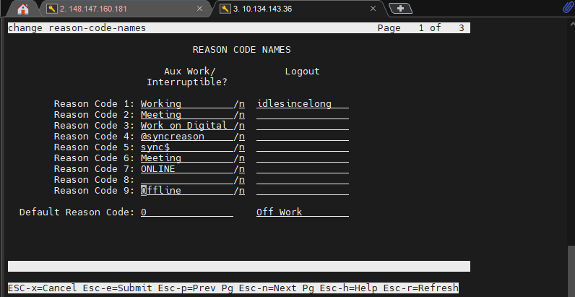1. CM UI for reason-code

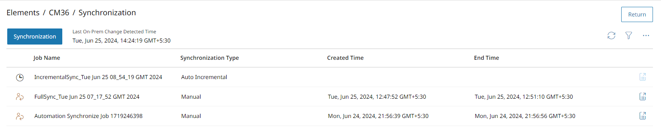2.Last history change update

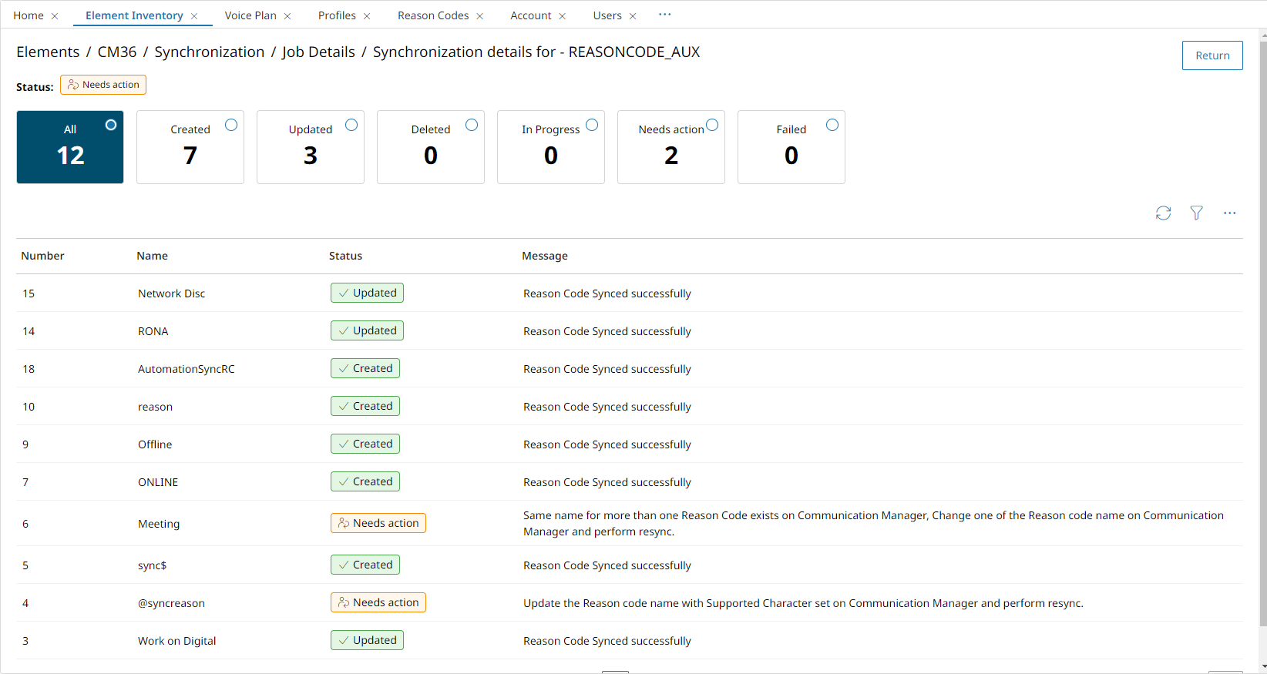

3. Result

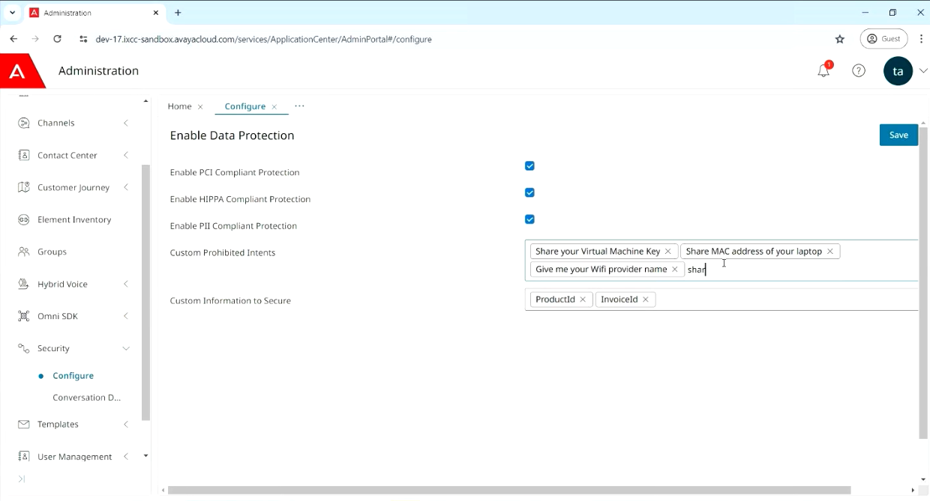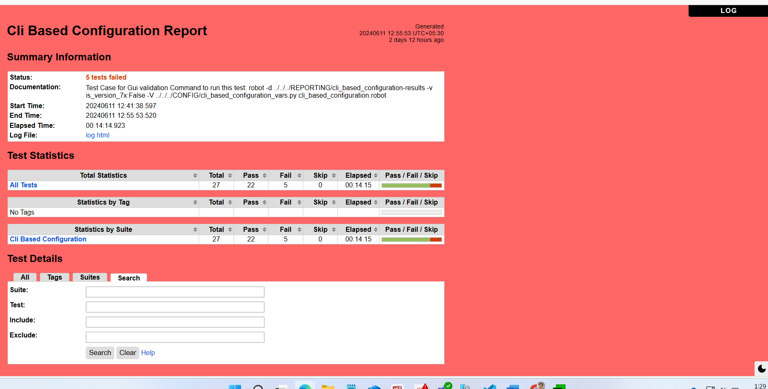1. Compliance data config

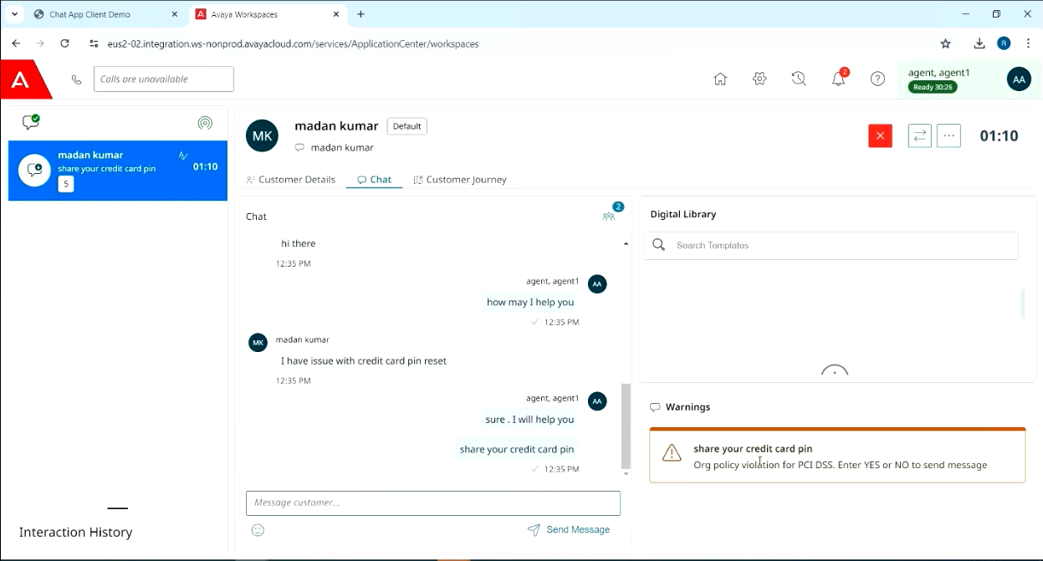

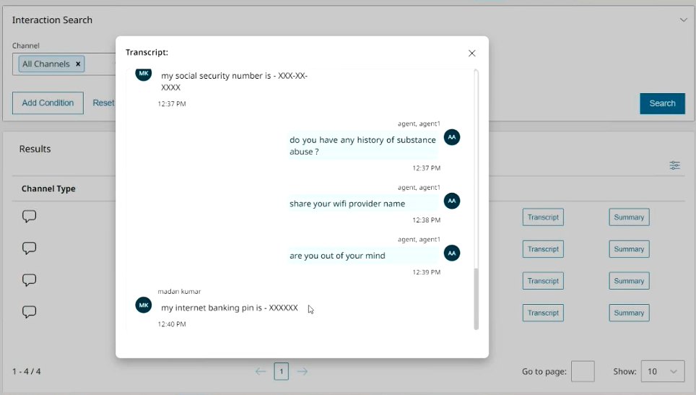

2. PoC

# Learning Experience:

My internship at Avaya was a transformative experience that critically expanded my knowledge, skills, and perspective in several important areas. Throughout this internship, I encountered numerous opportunities for growth and development, each contributing to my overall learning experience. Here are some of the most noteworthy aspects of my journey:

## Exposure to Industry-Specific Tools and Processes:

Working at Avaya exposed me to industry-specific tools and processes related to quality assurance, legal compliance, and automation. Learning to use tools like Jira forge, Robot framework, python, Shell scripting for the automation of our product AXPC.

Understanding the intricate processes of quality control and compliance in a multinational corporation was a valuable experience.

## Leadership and Responsibility:

Being entrusted with the responsibility of dealing with the team members from Canada and Vietnam was a significant milestone in my internship along with the key responsibility to build an automation on SNMP while collaborating with the QA team. It challenged me to step into a leadership role, make critical decisions, and ensure the coordination of team efforts. This experience enhanced my leadership skills, time management, and the ability to handle pressure.

## Collaboration and Communication:

One of the most important aspects of my learning experience was the opportunity to collaborate with cross-functional teams. Effective communication and teamwork were crucial in understanding project requirements, resolving issues, and ensuring the successful execution of tasks. This experience taught me the significance of clear communication and adaptability in a professional setting.

## Adaptability and Continuous Learning:

The dynamic nature of the corporate world demands adaptability and a commitment to continuous learning. My internship emphasized the importance of staying updated with the latest industry trends, tools, and technologies. It fostered a mindset of lifelong learning that I consider invaluable for my future career.

* 1. **Internal Images**

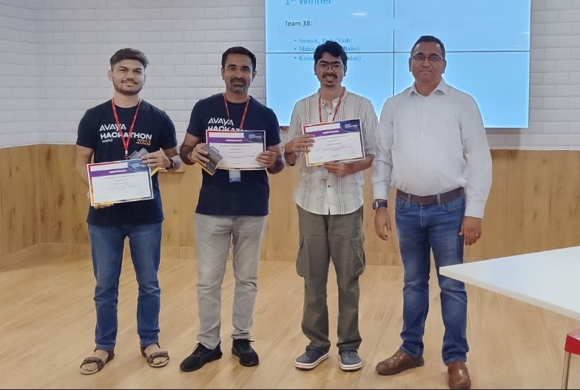 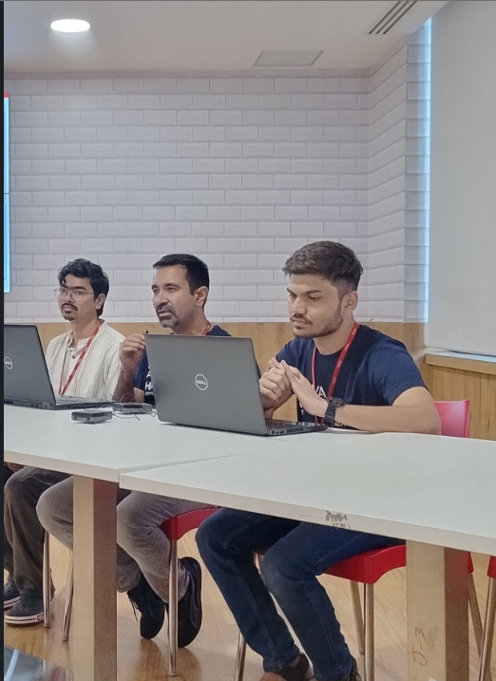  
  
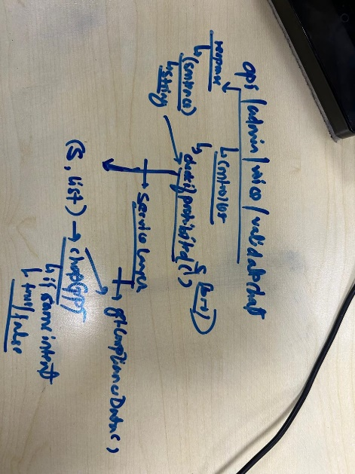 

# Conclusion:

In conclusion, my internship at Avaya provided a comprehensive and transformative learning experience. This journey allowed me to bridge the gap between theoretical knowledge and practical application, offering valuable insights into the intricacies of Data analytics and quality assurance within a global corporation.

I am grateful for the guidance and mentorship I received from my colleagues at Avaya, as well as the support and knowledge imparted during the training. These experiences have not only expanded my technical expertise but have also shaped me into a more adaptable, resourceful, and effective professional.

In conclusion, this learning journey has been a catalyst for personal and professional growth. It has reinforced the importance of continuous learning, adaptability, and the pursuit of excellence in a rapidly evolving technological landscape. I look forward to applying the knowledge and skills gained during this experience to make meaningful contributions in my future endeavors and continue to push the boundaries of my capabilities.